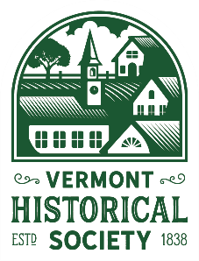
The Legacy Circle
Letter of Intent
- Yes! I have included the Vermont Historical Society in my estate plans.
Name _______________________________________________Date ________________________
Address __________________________________________________________________________
City, State Zip______________________________________________________________________
Phone __________________________________ Email ____________________________________
Type of gift:
- Will / Living Trust
- IRA / Retirement Account
- Bank, Brokerage, or Other Financial Account
- Charitable Trust
- Other (please specify) ___________________________________________________________
My future gift:
- Is a percentage of my estate and is worth approximately: $__________________
- Is in the specific amount of: $ __________________
- I wish to keep the value of my future gift confidential.
- My future gift is designated to support:
- Where it is most needed at the discretion of VHS Executive Leadership
- The Endowment Fund
- Specific Program (please specify) _________________________________________
Donor Recognition choices:
- I/we wish to remain anonymous and do not want this gift acknowledged in public.
- I/we would like to be acknowledged as a member of the Legacy Circle with the following wording:
Name of Individual(s) or family name _____________________________________________________
Signature ____________________________________________ Date __________________________
Please return this form to Kate Olney: Vermont Historical Society
60 Washington Street, Suite 1
Barre, Vermont 05641

